Racism in STEM and society: an abridged glossary of terms

To hear about these issues and how they impact the lives of talented Black scientists from these scientists directly, please see
- JAX Racism in STEM discussion
- Experiences of Black STEM in the Ivory: A call to disruptive action 2-day discussion (https://youtu.be/Be3NCsBsl-I and https://youtu.be/eUc2jnsWcRA)
- NeuroRacism Panel #BlackInNeuroWeek
- Check out #BlackintheIvory on Twitter

Ally: Someone who supports a group other than one’s own (in terms of multiple identities such as race, gender, age, ethnicity, sexual orientation, religion, etc.). An ally acknowledges oppression and actively commits to reducing their own complicity, investing in strengthening their own knowledge and awareness of oppression. (From: W.K. Kellogg Foundation. Racial Resource Guide)

Implicit bias: Negative associations expressed automatically, without conscious awareness that people unknowingly hold and that affect our understanding, actions, and decisions; also known as unconscious or hidden bias. (Potapchuk, M., Leiderman, S., et al. (2009). Glossary. Center for Assessment and Policy Development). To learn more about implicit bias and how it relates to other heuristics (cognitive frameworks that we use to categorize and interpret sensory data), see this video and the following series from UCLA: https://www.youtube.com/watch?v=BwYFhJO9t50
To learn about implicit biases in academia from the perspective of a graduate student of color, try Fair Play, a simulator that takes participants through the journey of a Black graduate student in academia.
The National Center for Women & Information Technology has some tips on interrupting bias here.

Antiracism: Antiracism, as championed by Ibram X. Kendi, holds that there is no neutrality when it comes to confronting systemic racism: our actions, ideas, and policies either support racism (directly or by maintaining the status quo) or they support antiracism, meaning they actively address and dismantle racist systems and promote racial equality. As Kendi states: “The opposite of “racist” isn’t “not racist”. It is “antiracist”. What’s the difference? One endorses either the idea of a racial hierarchy as a racist, or racial equality as an antiracist. One either believes problems are rooted in groups of people, as a racist, or locates the roots of problems in power and policies, as an antiracist. One either allows racial inequities to persevere, as a racist, or confronts racial inequities, as an antiracist. There is no in-between safe space of “not-racist”. The claim of “not racist” neutrality is a mask for racism.” (How to be an Antiracist). In addition to the book, see also Kendi’s discussion guide for those interested in book clubs and this video discussion.
The antiracism framework proposes specific definitions for racism in various forms:
Racist: One who is supporting a racist policy through their actions or inaction or expressing a racist idea.
Antiracist: One who is supporting an antiracist policy through their actions or expressing an antiracist idea.
Racist policy: Any measure that produces or sustains racial inequity between racial groups.
Antiracist policy: Any measure that produces or sustains racial equity between racial groups.
Racist idea: Any idea that suggests one racial group is inferior or superior to another racial group in any way.
Antiracist idea: Any idea that suggests the racial groups are equals in all their apparent differences-that there is nothing right or wrong with any racial group.
Kendi I.X. How to be an Antiracist
Systemic racism: Includes the policies and practices entrenched in established institutions at all levels, which result in the exclusion or promotion of designated groups. It differs from overt discrimination in that no individual intent is necessary. (Alberta Civil Liberties Research Centre, Forms of Racism). Watch this short history of housing discrimination in the US (redlining) to see one example of how racist policies reinforce generational poverty as well as educational, health, and policing disparities for people of color and the poor.

Diversity: Socially, it refers to the wide range of identities. It broad includes race, ethnicity, gender, age, national origin, religion, disability, sexual orientation, socioeconomic status, education, marital status, language, veteran status, physical appearance, etc. It also involves different ideas, perspectives, and values. (Potapchuk, M., Leiderman, S., et al. (2009). Glossary. Center for Assessment and Policy Development)

Equity: The fair treatment, access, opportunity and advancement for all people, while at the same time striving to identify and eliminate barriers that have prevented the full participation of some groups. The principle of equity acknowledges that there are historically underserved and underrepresented populations and that fairness regarding these unbalanced conditions is needed to assist in the provision of adequate opportunities to all groups. (Equity and Inclusion. Glossary. UC Davis)
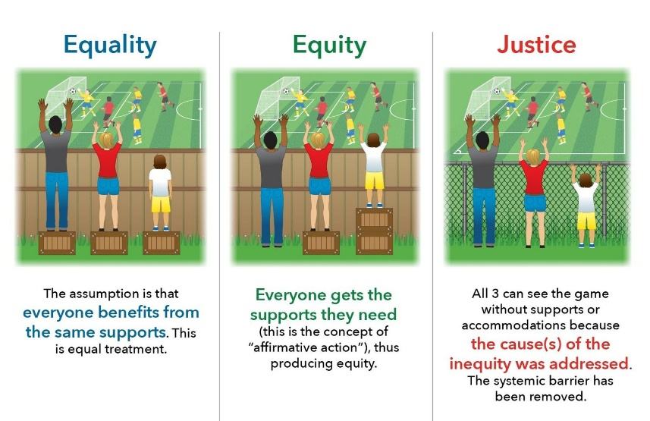
The contrast between equality, equity, and justice.
Inclusion: The act of creating environments in which any individual or group can be and feel welcomed, respected, supported and valued as a fully participating member. An inclusive and welcoming climate embraces differences and offers respect in words and actions for all people. (Equity and Inclusion. Glossary. UC Davis). Inclusion must go hand-in-hand with outreach and other diversity efforts. As HHMI’s David Asai has said: “Diversity without inclusion is an empty gesture” (To learn inclusion skills, make it personal)

BIPOC: Black, Indigenous, and People of Color. The term highlights the unique relationship to whiteness that Indigenous and Black (African Americans) people have, which shapes the experiences of and relationship to white supremacy for all people of color within a U.S. context. (https://www.thebipocproject.org/about-us)

Gaslighting: A manipulation tactic to make someone believe that he or she is going insane by subjecting that person to a series of experiences that have no rational explanation. Gaslighting is used to control and collect power. The three steps of Gaslighting: 1. Ideation. Gaslighters create a relationship where you think they’re wonderful. They create experiences of joy and camaraderie. 2. Devaluation. Gaslighters learn your strengths and weaknesses, hit you where it hurts, confuse you, and become unpredictable and uncertain. In this stage, they often try to give you advice, which reinforces your insecurities. An example would be saying, “You may want to think about how you come across when you speak.” 3. Discarding. Gaslighters play on your dependence of them, then discard you, aiming to lower your self-esteem. (Paul Smirl, “Combating Gaslighting in the Workplace: How to spot and extinguish this form of harassment”)
Please watch Manu Platt’s frank and honest discussion on gaslighting in society and academia in relation to Black Lives Matter.

Intersectionality: For a group or individual, representing more than one disadvantaged social category (race, sex, gender, ability status, socioeconomic level). For instance, the “double bind” for women of color in STEM fields who must confront racial and sex-based discimination is well-known, especially to those that experience it, and a reason for high rates of attrition for talented women of color in academia (Inside the double bind)

Identity contingencies: The things you have to deal with in a situation because you have a given social identity. I.e. Old, young, gay, Black, Latino, a woman, etc. (Whistling Vivaldi: How Stereotypes Affect Us and What We Can Do by Claude M Steele)

Performative allyship: Disingenuous or superficial acts or signs of support for social justice issues that serve to promote or advance the individual or group and not advance meaningful change. For example, a major company or organization adding a “Black Lives Matter” banner to their website, but not addressing hiring and promotion practices that disadvantage Black applicants and employees.

Microaggression: The verbal, nonverbal, and environmental slights, snubs, insults, or belittlement, whether intentional or unintentional, which communicate hostile, derogatory, or negative messages to target persons based solely upon discriminatory belief systems. (Potapchuk, M., Leiderman, S., et al. (2009). Glossary. Center for Assessment and Policy Development). Watch The Hidden Women of STEM to hear Mathematician Alexis Scott describe her experience of “invisibility” as a woman of color in academia.

Institutional racism - Institutional racism refers specifically to the ways in which institutional policies and practices create different outcomes and opportunities for different groups based on racial discrimination. (Potapchuk, M., Leiderman, S., et al. (2009). Glossary. Center for Assessment and Policy Development)

Cultural appropriation - The non-consensual/misappropriation use of cultural elements for commodification or profit purposes – including symbols, art, language, customs, etc. — often without understanding, acknowledgment, or respect for its value in the original culture. (Potapchuk, M., Leiderman, S., et al. (2009). Glossary. Center for Assessment and Policy Development)

Tokenism - Presence without meaningful participation. For example, a superficial invitation for the participation of members of a certain socially oppressed group, who are expected to speak for the whole group without giving this person a real opportunity to speak for her/himself. (Colors of Resistance. Definitions for the Revolution)

URM/Minority tax: The burden of extra responsibilities placed upon underrepresented communities by their institution to do the physical, mental, and emotional labor to fix/change the inherent and systemic issues that their institution holds. Usually this work does not count towards completion of the degree [for students], is not recognized in other contexts of the institution and there is usually none or very little financial compensation for the consulting work they do. (Brian Castellano, https://twitter.com/queerentist/status/1270167889455144960?s=20). For diverse academic medicine faculty, this extra burden is “a major of inequity in academic medicine”. (Addressing disparities in academic medicine: what of the minority tax?).

